CSD-325 Module 4: Flowchart and Program Output

Name: Reed Bunnell

Assignment: Bunnell 4.1

# Initial Flowchart - Original sitka_highs.py

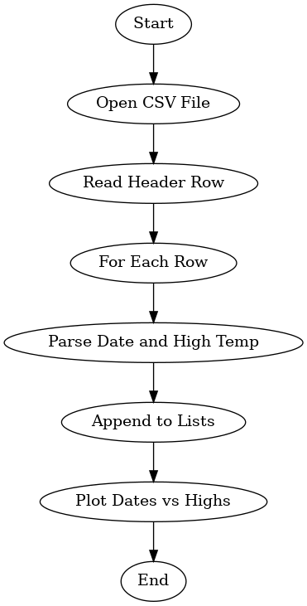

# Updated Flowchart - sitka_high_low_rb.py

